Help System Project Report
This document is a template for the report submission requirements for the Help System project.

Complete all sections as directed
Candidate Name: | Chris Alley
Submission Date:

Project Brief (Task 1 of the project)
The project brief is a planning document that is a specification of what your help system should achieve. A brief is formulated from client interviews, instructions and requirement specifications. You will use it later in the project to judge whether you have been able to produce the outcome your client required. Items should be a short but clear description of what your help system should achieve.
Project Purpose
To provide an HTML based help file that players of the GUI Hangman game can refer to if they get stuck with any aspect of the game. It should cover all the different features of the game.
Target Audience
The target audience is 10 – 12 year olds who are using the program to better their English skills.
Specification
Topics.  (Describe the topics to be contained in your help system. At least 5 topics should be identified) | Introduction
 | Getting Started
 | Playing the Game
 | Viewing Reports
 | Signing Off
 | About the Game
 | (Add more items if required)
Graphics  (Describe and/or copy samples of graphics your help system will contain. At least 5 graphics should be specified) | 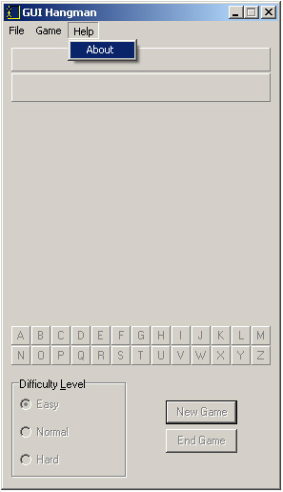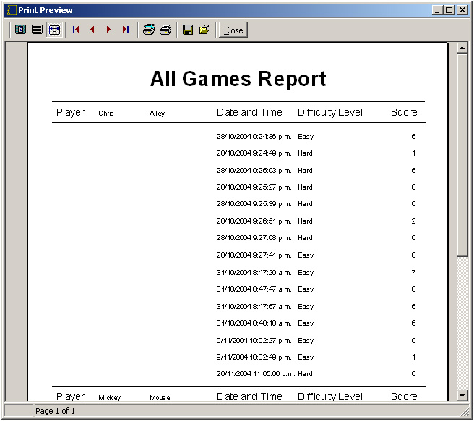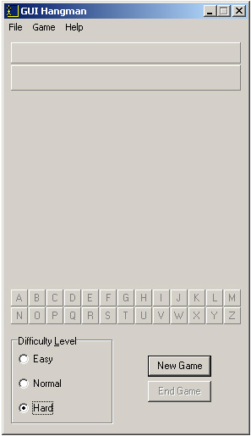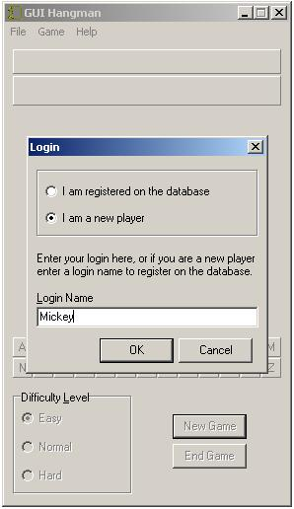
 | 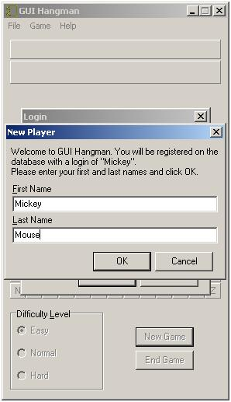
 | 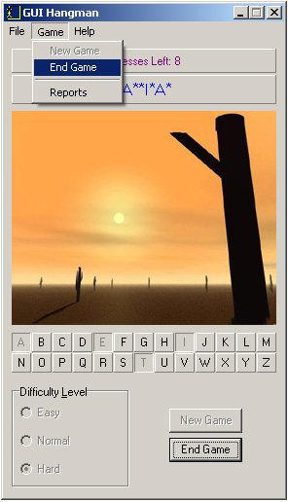
 | 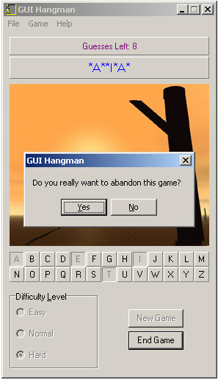
 | 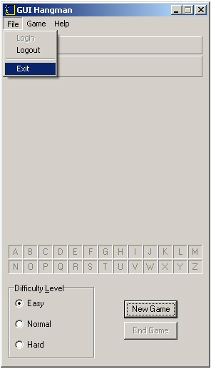
 | 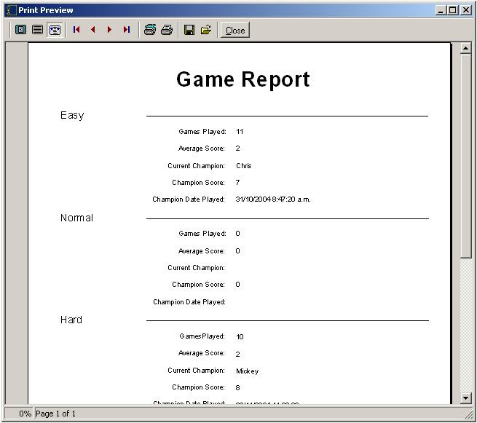
 | 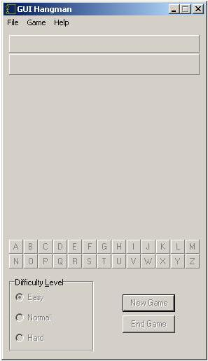
 | 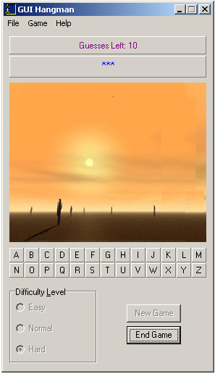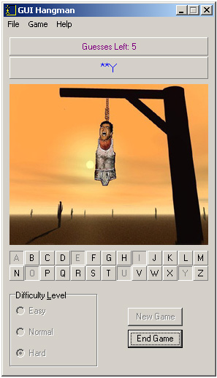
 | 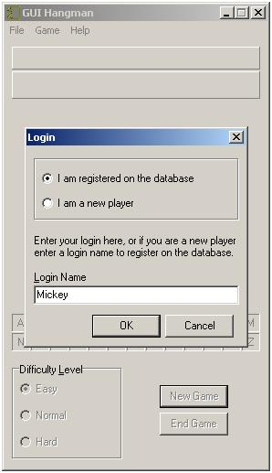
 | 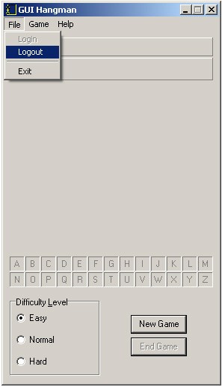
 | 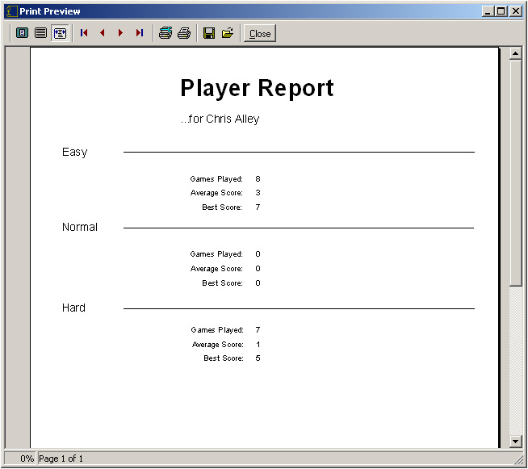
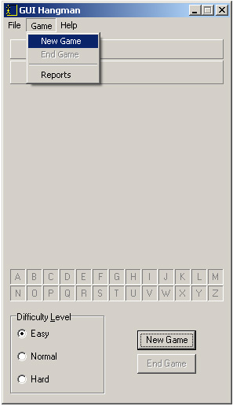
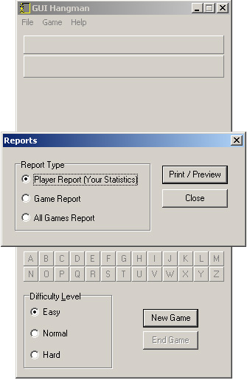

Text Format  (Supply descriptions and/or examples of the text formats your help system will use – headers, sub-headers, paragraphs, lists etc.. At least 3 samples should be specified) | There’ll be a heading at the top of each page describing what the page is about. Below the heading will be text, and for most pages and image or two that relates to the text. For main topics, there will often be a list of pages at the bottom of the page that are sub topics of the main topic.
Time Estimate  (Estimate the time required to develop the system.) | It will take approximately 1 or 2 days to plan and implement the help system.

Plan of Action
Provide short descriptions of the milestone steps you will go through to realise the project brief, and the estimated time to complete them. This plan must include a step where you test the prototype against the requirements of the project brief with your client (represented by your tutor). Specify at least 5 milestone steps.
Step No. | Description | Est. Time
1 | Plan the project | 2 hours
2 | Capture screenshots for use in the help system | 1 hour
3 | Write the HTML files and their content | 4 hours
4 | Create the project in HTML Help Workshop | 2 hours
5 | Add the index and search functions to the project | 2 hours
(Add more rows if required)

Total estimated time: | 11 hours

Test Report (Task 3 of the project)
Complete all sections of this report.

Navigation Test
Table of contents Test: Verify that links from the Table of Contents connect to the correct page. All headings and topics in the Table of Contents must be tested.
TOC Title | Link Page Title/Header
Introduction | Introduction
Getting Started | Getting Started
Creating a New Player | Creating a New Player
Logging On | Logging On
Playing the Game | Playing the Game
Choosing a Difficulty Level | Choosing a Difficulty Level
Starting a New Game | Starting a New Game
How to Play | How to Play
Ending a Game | Ending a Game
Viewing Reports | Viewing Reports
Player Report | Player Report
Game Report | Game Report
All Games Report | All Games Report
Signing Off | Signing Off
Logging Out | Logging Out
Exiting the Game | Exiting the Game
About the Game | About the Game

Hyperlinks Test: Verify that hyperlinks connect to the correct page. All hyperlinks must be tested.
Hyperlink Page Title | Hyperlink Text | Link Page Title
Introduction | Getting Started | Getting Started
Getting Started | Log on to the database | Logging On
Getting Started | Create a new player profile | Creating a New Player
Logging On | Created a new account | Creating a New Player
Playing the Game | Choosing a Difficulty Level | Choosing a Difficulty Level
Playing the Game | Starting a New Game | Starting a New Game
Playing the Game | How to Play | How to Play
Playing the Game | Ending the Game | Ending the Game
Starting a New Game | Logging on | Logging On
How to Play | Started a new game | Starting a New Game
Viewing Reports | Logged in | Logging On
Viewing Reports | Player Report | Player Report
Viewing Reports | Game Report | Game Report
Viewing Reports | All Games Report | All Games Report
Signing Off | Logging Out | Logging Out
Signing Off | Exiting the Game | Exiting the Game

Related Topics Test: Verify that related topics connect to the correct page. All sub-topics of related topic buttons must be tested.
Button Page Title | Related Topic Title | Jump Page Title
(Add more rows as required)

Graphics Test
Verify that graphics appear correctly and are appropriate for their context. All graphics must be tested.
Graphic Page Title
Getting Started
Creating a New Player
Creating a New Player
Logging On
Choosing a Difficulty Level
Starting a New Game
How to Play
How to Play
Ending a Game
Ending a Game
Viewing Reports
Player Report
Game Report
All Games Report
Logging Out
Exiting the Game
About the Game

Evaluation Report (Task 3 of the project)
Review your completed help system and identify strengths, limitations and suggestions for future improvement.

Strengths
The help system covers all of the different commands of the actual program, and explains how to play hangman. It has screenshots for most of the pages which shows the player how to access specific commands.
Limitations
The screenshots aren’t informative straight away, they’re basically just pictures of what the screen looks like, not whereabouts on the screen the command or feature actually is. The instructions on how to play hangman could also be a bit more detailed.
Suggestions for future improvement
I could add arrows pointing to the commands/features that were being explained in each screenshot to make things clearer for the player seeking help.

User Document
Note: The user document for the help system is to be used by teachers so they can instruct students on how to use the system. You can make the following assumptions:
- Teachers are qualified to use, and are familiar with computers running the Microsoft Windows operating system.
- Teachers are familiar with help systems for Windows applications, but not necessarily familiar with HTML help systems.
- The installation program for the GUI Hangman project creates access to your help system by placing an icon on the desktop and by installing an item in the Hangman Submenu of the Start Menu.
1. Write a short description of the purpose of your help system.
The purpose of the help system is to provide students who use the game to have a way of progressing further in the game if they get stuck with navigating through the interface or understanding how hangman is played. If students get stuck they can consult the help without having to go to an actual person to ask for help.
2. Write some brief instructions on how to start your help system, and on how to use the system.
Double click the help icon on the desktop to open the help file.
You can navigate around the help system using the left hand pane. Clicking on a heading will open up a corresponding page in the right hand pane. Clicking on the closed book icons opens up a list of sub headings below the main heading, each of which can be clicked on for further help.
Various links will appear on the pages. Clicking on them will open up further info on the subject.
There are three tabs up the top of the left hand pane – Contents, Index, and Search. Clicking on them will change the contents of the left pane.
If the Index is open you can double click on a keyword and a list of topics will be brought up relating to that keyword.

